**NAME: AMMAAR AHMAD**

**ROLL NO: 1801CS08**

**CS322 LAB 9**

1. Old Control Unit with bugs

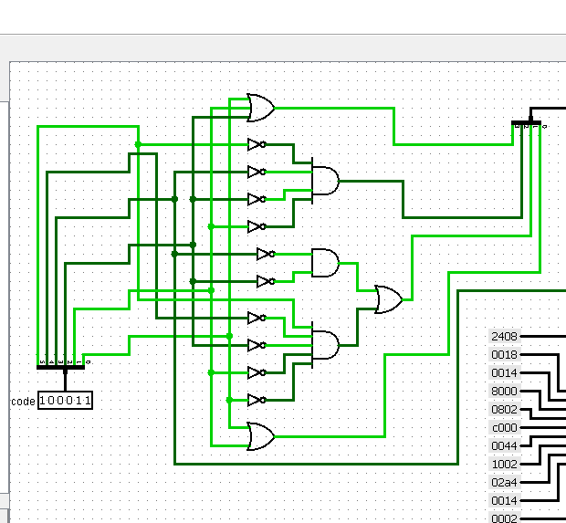

Changes:

lw (100011) - 0010 Beq (000100) - 1000

sw(101011) - 0010 J (000010) - 1011

addi (001000) - 1001 andi (001100) - 1001

R Type (000000) – 0110

New Control Unit without bugs

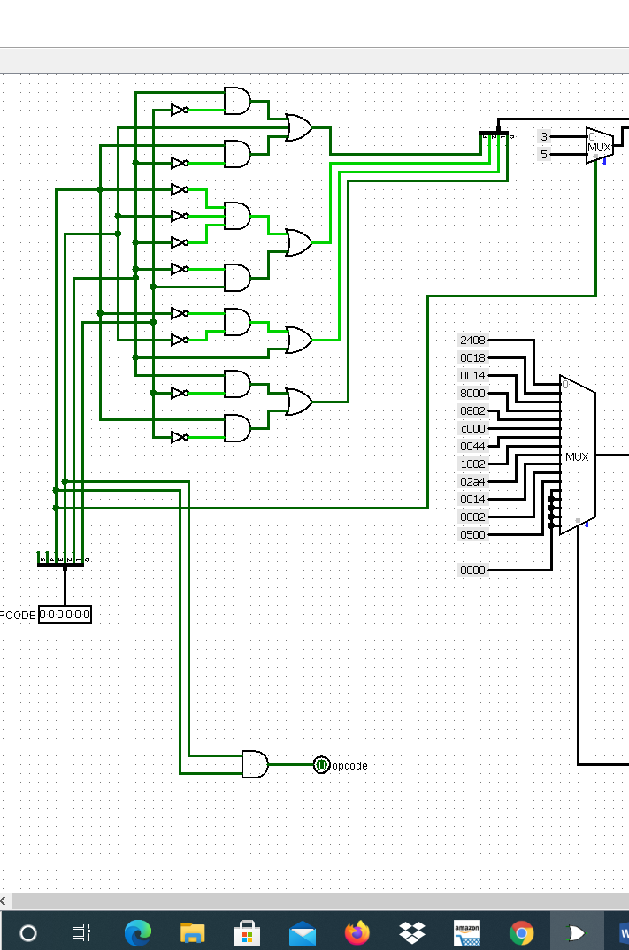

1. Program to add 5 numbers.

Initially 5 numbers are stored in registers no 1 to 5.

$1 = 34, $2 = 21, $3 = 15, $4 = 45, $5 = 12, Result of addition $6 = 0 initally

All numbers are in hexadecimal form. Final Result $6 = C1(Hex)

52+33+21+69+18=193=C1(Hex)

MIPS code Machine Code

addi $1, $0, 52 0x20010034

addi $2, $0, 33 0x20020021

addi $3, $0, 21 0x20030015

addi $4, $0, 69 0x20040045

addi $5, $0, 18 0x20050012

addi $6, $0, 0 0x20060000

add $6, $1, $2 0x00223020

add $6, S3, $6 0x00663020

add $6, $4, $6 0x00863020

add $6, $5, $6 0x00A63020

sw $6, 32($0) 0xAC060020

ROM loaded with Machine Code

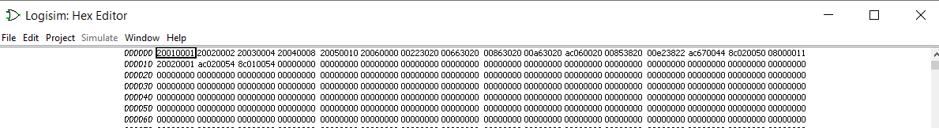

After addition $6 stores value C1 or 193 in decimal

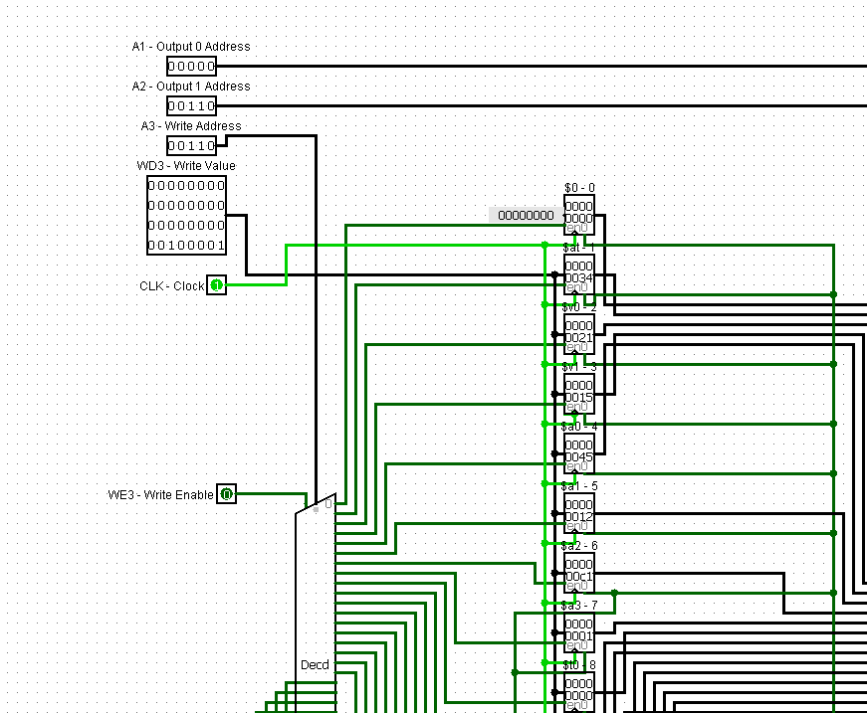

1. Adding new instruction andi (001100) to the circuit

Program to add 5 numbers and then mask last 4 bits

Initially 5 numbers are stored in registers no 1 to 5.

$1 = 34, $2 = 21, $3 = 15, $4 = 45, $5 = 12, Result of addition $6 = 0 initally

All numbers are in hexadecimal form. Final Result $6 = C1(Hex)

52+33+21+69+18=193=C1(Hex)

MIPS code Machine Code

addi $1, $0, 52 0x20010034

addi $2, $0, 33 0x20020021

addi $3, $0, 21 0x20030015

addi $4, $0, 69 0x20040045

addi $5, $0, 18 0x20050012

addi $6, $0, 0 0x20060000

add $6, $1, $2 0x00223020

add $6, S3, $6 0x00663020

add $6, $4, $6 0x00863020

add $6, $5, $6 0x00A63020

andi $7, $6, 15 0x30c7000f

sw $6, 32($0) 0xAC060020

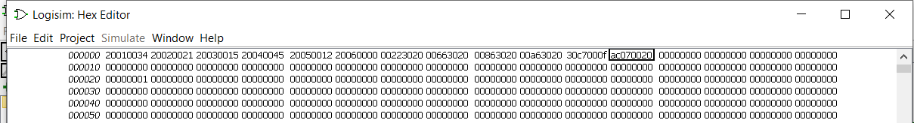

New ALU circuit after adding new instruction andi

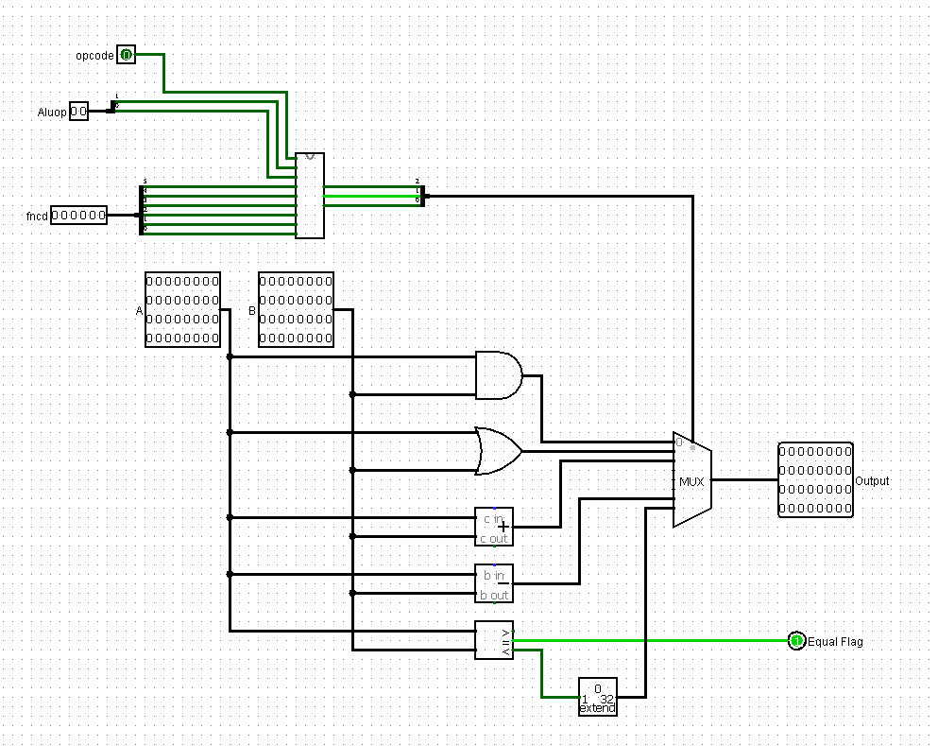



Output in $7 register => 0xC1 & 0xf = 0x1